**New Part result**

[**BBa_K3981015**](http://parts.igem.org/Part:BBa_K3981015)

请将下面内容放置**[BBa_K3981015](http://parts.igem.org/Part:BBa_K3981015)** 的main page页

Based on the ISZ-sTRAIL expression vectors, a sequence of Her2-affibody, which could increase the target effect of ISZ-sTRAIL, was added to the N-terminus of ISZ-sTRAIL plasmid to construct a new part of pET-28a(+)-His-linker-Her2-ISZ-sTRAIL ([**BBa_K3981015**](http://parts.igem.org/Part:BBa_K3981015), Her2- ISZ-sTRAIL for short) recombinant vector.

**1. Construction of Her2-ISZ-sTRAIL expression plasmid**

The coding sequence of Her2-ISZ-sTRAIL with a His-tag were designed by our group, then synthesized and cloned into pET-28a(+) expression vector by company. Fig.1 showed the map of the obtained pET-28a(+)-His-linker-Her2- ISZ-sTRAIL recombinant plasmid.

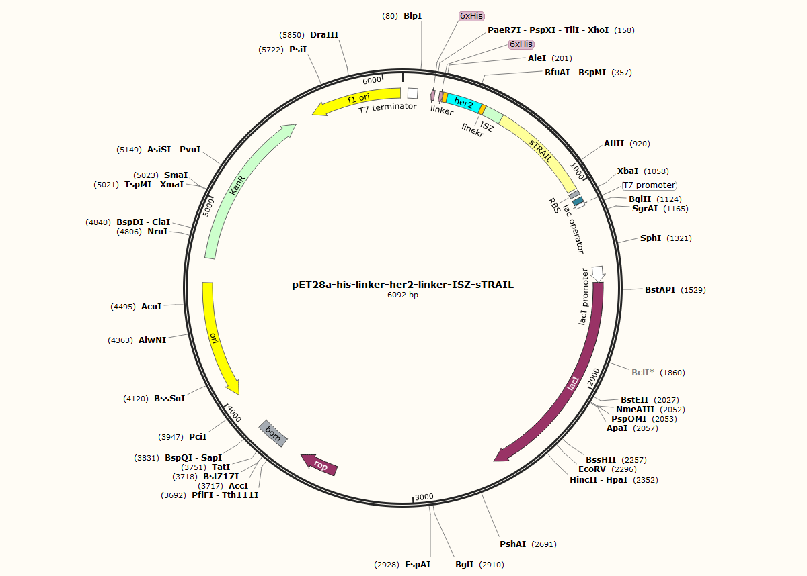

Fig 1. Map of Her2-ISZ-sTRAIL recombinant vector

**2. Establishment of an engineered E. coli BL21(DE3) strain for expression of Her2-ISZ-sTRAIL protein**

**2.1 Transformation**

The Her2-ISZ-sTRAIL expression plasmids were then transformed into E. coli BL21 (DE3), and positive clones were selected on the basis of kanamycin resistance. Many positive clones were grown on the plates (Fig. 2).

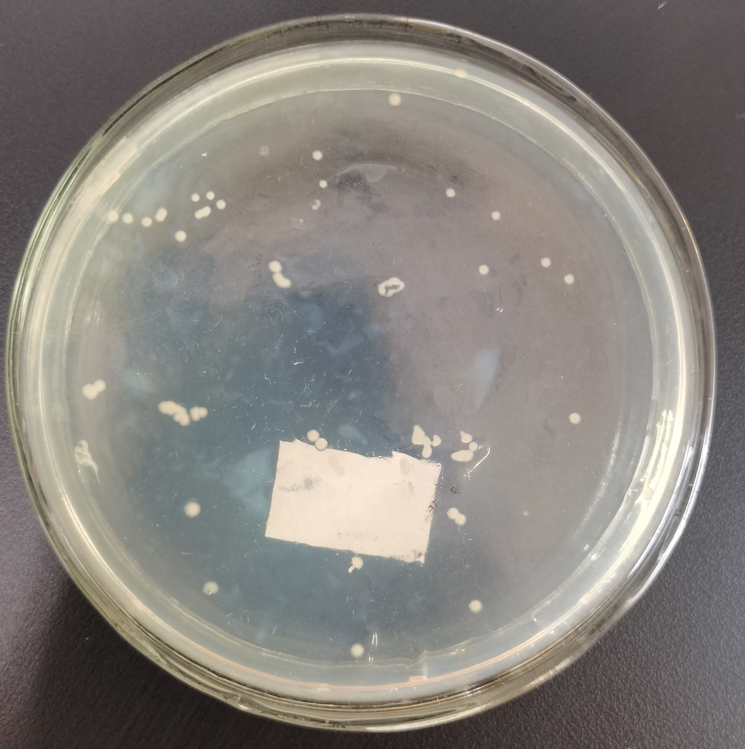

Fig. 2 Positive colonies harboring Her2-ISZ-sTRAIL expression plasmids grown on the plate with kanamycin

**2.2 Induced expression of Her2-ISZ-sTRAIL protein in E. coli BL21 (DE3)**

Then, with an IPTG concentration of 0.8 mM, the expression of Her2-ISZ-sTRAIL in the recombinant E. coli BL21 (DE3) was induced. The cells were lysed by sonication on ice, the obtained crude extract was centrifuged to separate the supernatant from debris, and the two parts were respectively subjected to SDS-PAGE. The arrow indicated in Fig. 3 was the band of Her2-ISZ-sTRAIL protein, which was consistent with the molecular weight of Her2-ISZ-sTRAIL -- about 32 kDa. It can be seen from lane 1 and 2 that IPTG apparently induced the expression of Her2-ISZ-sTRAIL protein. The results in lane 2 and 3 indicated that Her2-ISZ-sTRAIL was mainly expressed in the supernatant of cell lysate, demonstrating that Her2-ISZ-sTRAIL could be expressed as soluble protein in our engineered E. coli.

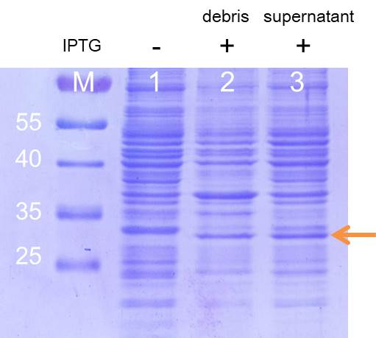

Fig. 3 SDS-PAGE analysis of induced Her2-ISZ-sTRAIL expression in E. coli BL21(DE3)

**3. Purification of Her2-ISZ-sTRAIL protein**

After confirming that Her2-ISZ-sTRAIL could be expressed in E. coli BL21 (DE3), the Her2-ISZ-sTRAIL protein was further purified with a nickel column. A clear band with the correct molecular weight was shown in Fig. 4. Western blot analysis using antibody for Histidine further demonstrated that this band was Her2-ISZ-sTRAIL protein (Fig. 5), suggesting that Her2-ISZ-sTRAIL was efficiently purified.

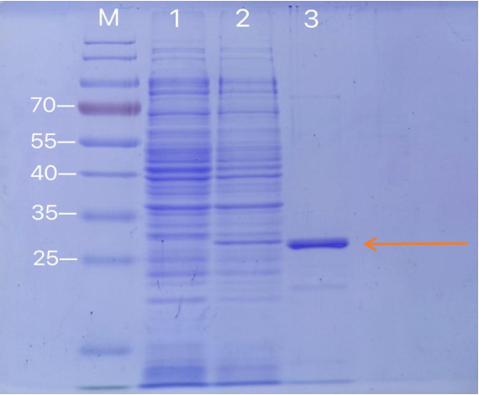

Fig 4. Her2-ISZ-sTRAIL protein was purified by Ni column and different fractions were analyzed by SDS-PAGE. Lane M: Protein marker; Lane 1: cell lysates without IPTG induction; Lane 2: cell lysates with IPTG induction; Lane 3: purified Her2-ISZ-sTRAIL protein.

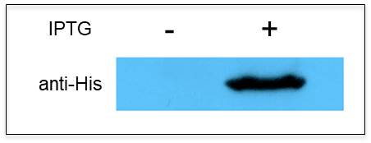

Fig. 5 Western blot analysis of purified Her2-ISZ-sTRAIL protein.

**4. Biological activity of Her2-ISZ-sTRAIL protein**

Finally, MTT assay was applied to test the potential toxicity of Her2-ISZ-sTRAIL protein on Her2-positive BT-474 breast cancer cells, and the result showed that the purified Her2-ISZ-sTRAIL protein could efficiently inhibit the growth of BT-474 cells (Fig. 6).



Fig. 6 In vitro toxicity effect of Her2-ISZ-sTRAIL protein on BBT-474 cells via MTT assay

In conclusion, an engineered E. coli BL21(DE3) could efficiently express soluble Her2-ISZ-sTRAIL protein with potential anti-tumor activity was successfully constructed.

Reference:

[1] Zielinski R, Lyakhov I, Hassan M, et al. HER2-affitoxin: a potent therapeutic agent for the treatment of HER2-overexpressing tumors. Clin Cancer Res. 2011 Aug 1; 17(15):5071-81.

[2] Zielinski R, Lyakhov I, Jacobs A, et al. Affitoxin--a novel recombinant, HER2-specific, anticancer agent for targeted therapy of HER2-positive tumors. J Immunother. 2009 Oct; 32(8):817-25.